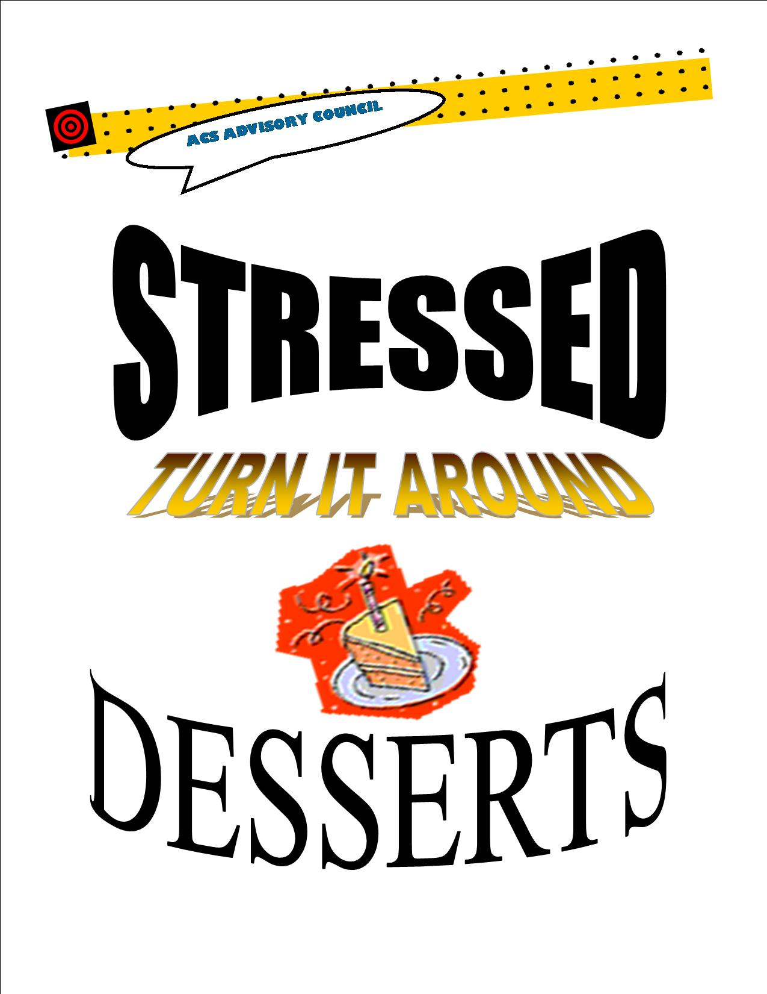

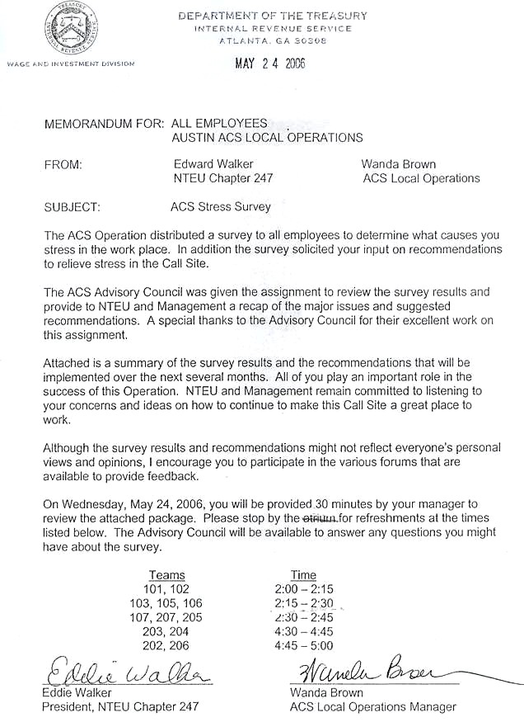

ACS ADVISORY COUNCIL

REDUCING STRESS IN THE ACS WORK ENVIRONMENT

The ACS Advisory Council was given the assignment to address stress in the ACS work environment and its causes. The Council conducted a survey of ACS Operation Collection Representatives (CRs), reviewed the results and submitted recommendations to reduce the stress levels in the ACS work environment. CR responses pointed to management issues, inconsistencies in work procedures, overall stress, leave denials, lack of adequate read time and Lead issues as the most compelling causes of stress in the call site. The following actions are being adopted by the Call Site :

- Management Issues - Concerns dealt with some manager’s lack of respect, overly critical managers, expectation vs. perfection and the lack of managerial communication skills. Other management issues included favoritism by some managers and upper management.

Recommendation:
ACS Operations Chief to discuss with managers:
a. The importance of maintaining a positive attitude.
b. Professional and effective communication.
c. Keeping all mannerism with employees professional.

Action:
ACS Operations Chief will inform managers of the need for positive communication and feedback to employees.

Recommendation:
Provide training for managers: “Managing in a Stress Environment”. Seminar, training, and/or classes taught by internal instructors (Dr. Bloom, Keith Stuckey etc.) or external vendors (National Seminars Group).

Action:
First formal meeting with manager’s scheduled for April 17th at the manager’s CPE class. Topics will include: (1) Communication workshop and Coaching (2) Team Building Skills. Additional training is planned throughout the year.

Recommendation:
Communication meetings - One team meeting per month (30 min.) devoted to team-building where team members can express ideas to make the team function better.

Action:
30 minutes (monthly) of a team meeting can be dedicated to team building. Team members will discuss team concerns and ideas for improvement. Team members will determine by consensus when time is needed to devote to team building.

Recommendation:
Renew the ACS Solicitation of Interest - Offer employees an opportunity to communicate their interest in different areas of development and advancement, allowing equal opportunities.

Action:
Solicitation Interest sheet has been revised and reissued to employees for available opportunities. See attachment A.

- Work Procedure Inconsistencies - Concerns varied from untimely communication regarding updates, local procedures, and inaccuracies with DI, and inconsistencies with teams and call sites. CR’s will no longer be burdened from the stress of keeping tabs and understanding the many updates and alerts that occur daily. Through the sharing of information we hope to see improvement in reduction of work related stress and ultimately an increase in QUALITY.

Recommendation:
Quality Tech(s) review and approve Tech meeting notes before they are distributed to the work groups. They will be discussed and communicated to the Techs to insure all are implementing the same procedures.

Action:
Quality Tech, will review and present alerts and provides details for procedural changes to insure all call site teams are adhering to IRM. Tech meeting notes are reviewed and structured to adhere to IRM before being distributed to employees.

Recommendation:
Job Aids - The tools that will be implemented to keep us all constantly updated on technical issues are as follows: job aids, IRM and e-ACSG.

Action:
Quality team (currently Ivory and Frances) are the only designated person(s) to put out job aids. Job aids, to ensure consistency, will be developed as needed. See attachment B. Job aid example.

Recommendation:
Ensure lead meetings are held as scheduled.

Action:
Tech meetings will be held as scheduled and/or will be setup for the next available day instead of waiting for the next scheduled Tech meeting. (Currently every 2 weeks)

- Overall Stress - Stress is constant in a work environment where the emphasis by management is to work faster and be constantly reminded (negatively) about average handle time and eWFM requirements.

Recommendation:
Stress Buttons to allow time for stressful calls.

Action:
ACS Operations and NTEU agree that the Memorandum of Agreement between the Internal Revenue Service and the National Treasury Employees Union (MOU) should be reviewed by employees when dealing with a stressful call. See Section 6 Auto Available Paragraph C. “There will be occasions when an employee determines the need to be off the phone as a result of a stressful customer contact, e.g., interaction with an irate customer. * In these situations, the current practice is to advise your manager.

Recommendation:
Stress Management Class - Schedule an interactive class during CPE or
Development Day on stress management for all ACS employees.

Action:
Development Day Speaker: Donald Hudson – Topic = Balancing the stress caused by completing priorities at home and work. These interactive sessions will provide stress management tools and techniques that can be applied anywhere and at almost anytime.

Recommendation:
Flyers - Prepare bi-monthly flyers utilizing humor or cartoon caricatures to
provide ways to a less stressful lifestyle.

Action:
ACS Operations agreed to flyers. Flyers will be developed and given to each employee once a month by the Advisory Council. See attachment C.

Recommendation:
Stress Tool - Each ACS employee will be provided with a stress reliever tool.

Action:
ACS Operations and NTEU will provide a “stress reliever” tool and distribute during Development Day, June 20, 2006.

- Leave Denials - Some employees indicated that EOD was not a good way to approve leave. Although this is a National agreement, some employees had specific concerns about employees with a high EOD abusing time granted.

Recommendation:
Ensure that leave approved is used or thrown back. Employees that continuously request leave but do not use it will be counseled by their manager.

Action:
First line managers will encourage employees to give back unused approved leave not taken. Appeal to all employees to encourage “Time For Others”. Turn in approved leave you will not use to allow your fellow coworkers an opportunity to benefit from their previously denied leave.

Recommendation:
Continue to prepare a calendar that shows available days.

Action:
“Available Days” calendar will be posted on the bulletin boards for Department 1 & 2 and upstairs for Team 101 each quarter by SA Julie McDermott. See attachment D.

- Lead Issues - Leads are not always available to answer technical questions. Concerns varied from the lack of respect some leads have for employee questions, to being too busy to answer questions. Some stress was due to pressing the “supervisor” button and no one “available” to answer questions. The surveys indicated that leads were leaving their desk but not changing their aspect code or simply not signing on to the aspect.

Recommendation:
A list of buddy managers and buddy leads will be given to each employee.

Action:
List of assigned buddy managers and buddy leads will be distributed to each employee. See attachment E.

Recommendation:
Mandate all leads regardless of workload to stay available on the phones.

Action:
All leads will be signed on Aspect and available for questions.

Recommendation:
Leads should be available on the Aspect system at all times, except when servicing CRs at their desk or on the floor. Managers should be in idle on the Aspect system to allow rollover from lead to buddy lead. Managers remaining available on Aspect are expected to answer rollover calls.

Action:
Correct idle codes usage made known to both managers and leads.

- Read Time - Although there were many more stress indicators from the surveys the last most common concern from the employees, regarding stress, the Advisory Council discussed in detail is the amount of changes that take place in ACS, and the short time they have to absorb them. The employees communicated in the surveys that they did not have enough read time.

Recommendation:
Communicate in team meetings to request for additional read time as needed.

Action:
ACS Operations and NTEU agree that the Memorandum of Agreement between the Internal Revenue Service and the National Treasury employees Union (MOU) should be reviewed by employees regarding read time. See Section 2. Read time/Meeting time. Paragraphs C “…additional read time will be granted by the employee’s manager at a time that fits with workload considerations.

Recommendation:
Keep a log of read time requested to ensure employees are provided the
additional read time.

Action:
Manager will call gatekeeper and request additional read time. Gatekeeper keeps a log of requests and informs manager when best available times can be
allocated.

Recommendation:
Mandate managers cover technical issues before administrative issues to ensure all important technical issues are addressed.

Action:
Technical issues will be covered at the beginning of team quality meetings.

CRITICAL QUOTES

QUOTES GIVEN FROM EMPLOYEES RELATING TO THE QUESTION:

WHAT CAUSES YOU STRESS IN THE WORKPLACE?

1) “Wanda says don’t worry about handle time while learning new FIN procedures but Mngr says to watch handle time. 2) Lack of clarity on new fin procedures (Leads & Mngrs not in agreement)”. 3) “Hurry, Hurry, Hurry (emphasis appears to be on getting it done fast rather than done right)”.

“STOP THE FAVORITISM”

“When you are told time spent on one call. Time spent on idle time. Being told to do it one way then in less than a week or two it changes to another way…”

“Nit picky managers & leads especially when they are confrontational or their approach is negative and pushy”.

“The weekly balanced measures emails- reminding us of our goals and how we’re missing them”.

“Having a workleader who acts put out when you have a questions, and who occasionally laughs at the fact that “you’re new” and so believe naively what the taxpayer is telling you”.

“Managers that don’t trust employees”.

“Managers should not talk about other team members with other team members or manager or leads”.

“Constant changing of the IRM/Local AUSC creating own procedures that don’t coincide with IRM (ie: levy release determination after IA agreed upon)”.

“Stress caused by dis-interested management”.

“Attitude of management that employees are stealing time, etc.”

“Leads that are not helpful and make smart remarks when you ask questions”.

“Management that says handle-time based on case but when doing yearly evaluation only looks at the numbers to determine if you met the requirements”.

“Too many changes too often, added responsibilities without matching compensation (ie: pay grade increase or grade change)”.

“Borderline harassment causes low moral, absence; no longer enjoy job or work environment.

“I’m too blessed….to be stressed…..” “Thank you. I love my job!!!”

“Annual leave denials”

“When almost everyone in ACS has such a negative attitude, it’s hard to stay positive. They pull you down to being negative”.

“When you see Mgrs, section, Div walk around with a scowl on their face”.

“We don’t even have time to say hello to people in our own unit”.

“When one site (Kansas) has different instruction than we do”.
CRITICAL QUOTES

QUOTES GIVEN FROM EMPLOYEES RELATING TO THE QUESTION:

DO YOU HAVE ANY RECOMMENDATIONS TO RELIEVE YOUR STRESS?

“Have fun time like we used to. Do something that will make people laugh. If a rule is set make sure all abide, not just part of the W&I ACS…. .”

“N/A, But I know there are some ACS employees that ought to transfer to a job that does not have a lot of stress. (Based on that employees mental state).”

“Get managers to work some calls, to show the CSRs how to do it correctly, in double-jacking.”

“Get the JOC schedule before you request annual leave requests from CSRs”

“Try Jesus Christ”

“More RAM installed on computer ( I think would speed things up).” “Better monitors”.

“Build fitness center w/lots of punching bags.”

“Management should stop lying to us”.

“Managers should care what the procedures are. Currently they only care about handle time”.

“It’s bad enough to have taxpayers yelling at you but to have a manager get in your face and call you a liar - well it just needs to stop”.

“No, I guess this is a facet of all jobs where thought processes are required”.

“Communicate, from highest management level on down, that numbers don’t necessarily equate to performance…..”.

“Management lighten up”. “Put some fun in our work……”

“Let CSRs collect taxes, factors in “common sense” & “human condition” for response to levy releases, financial info”.

“I would like also to see more of the reports that the “analysts” so diligently work all day to produce”.

“It would also be nice to know what calls we are having routed to us on a daily basis. The gatekeeper should notify the manager on a daily basis, so that information may be shared with the group”

“Be able to offer TAC office for in-person assistance”.

“Management needs to ease up on non-flexible stringent rules and allow CSRs to collect taxes w/out constant micro-management”!!

“Listen to CSRs & union reps when we share ideas that we (CSRs) are unhappy in our job”.

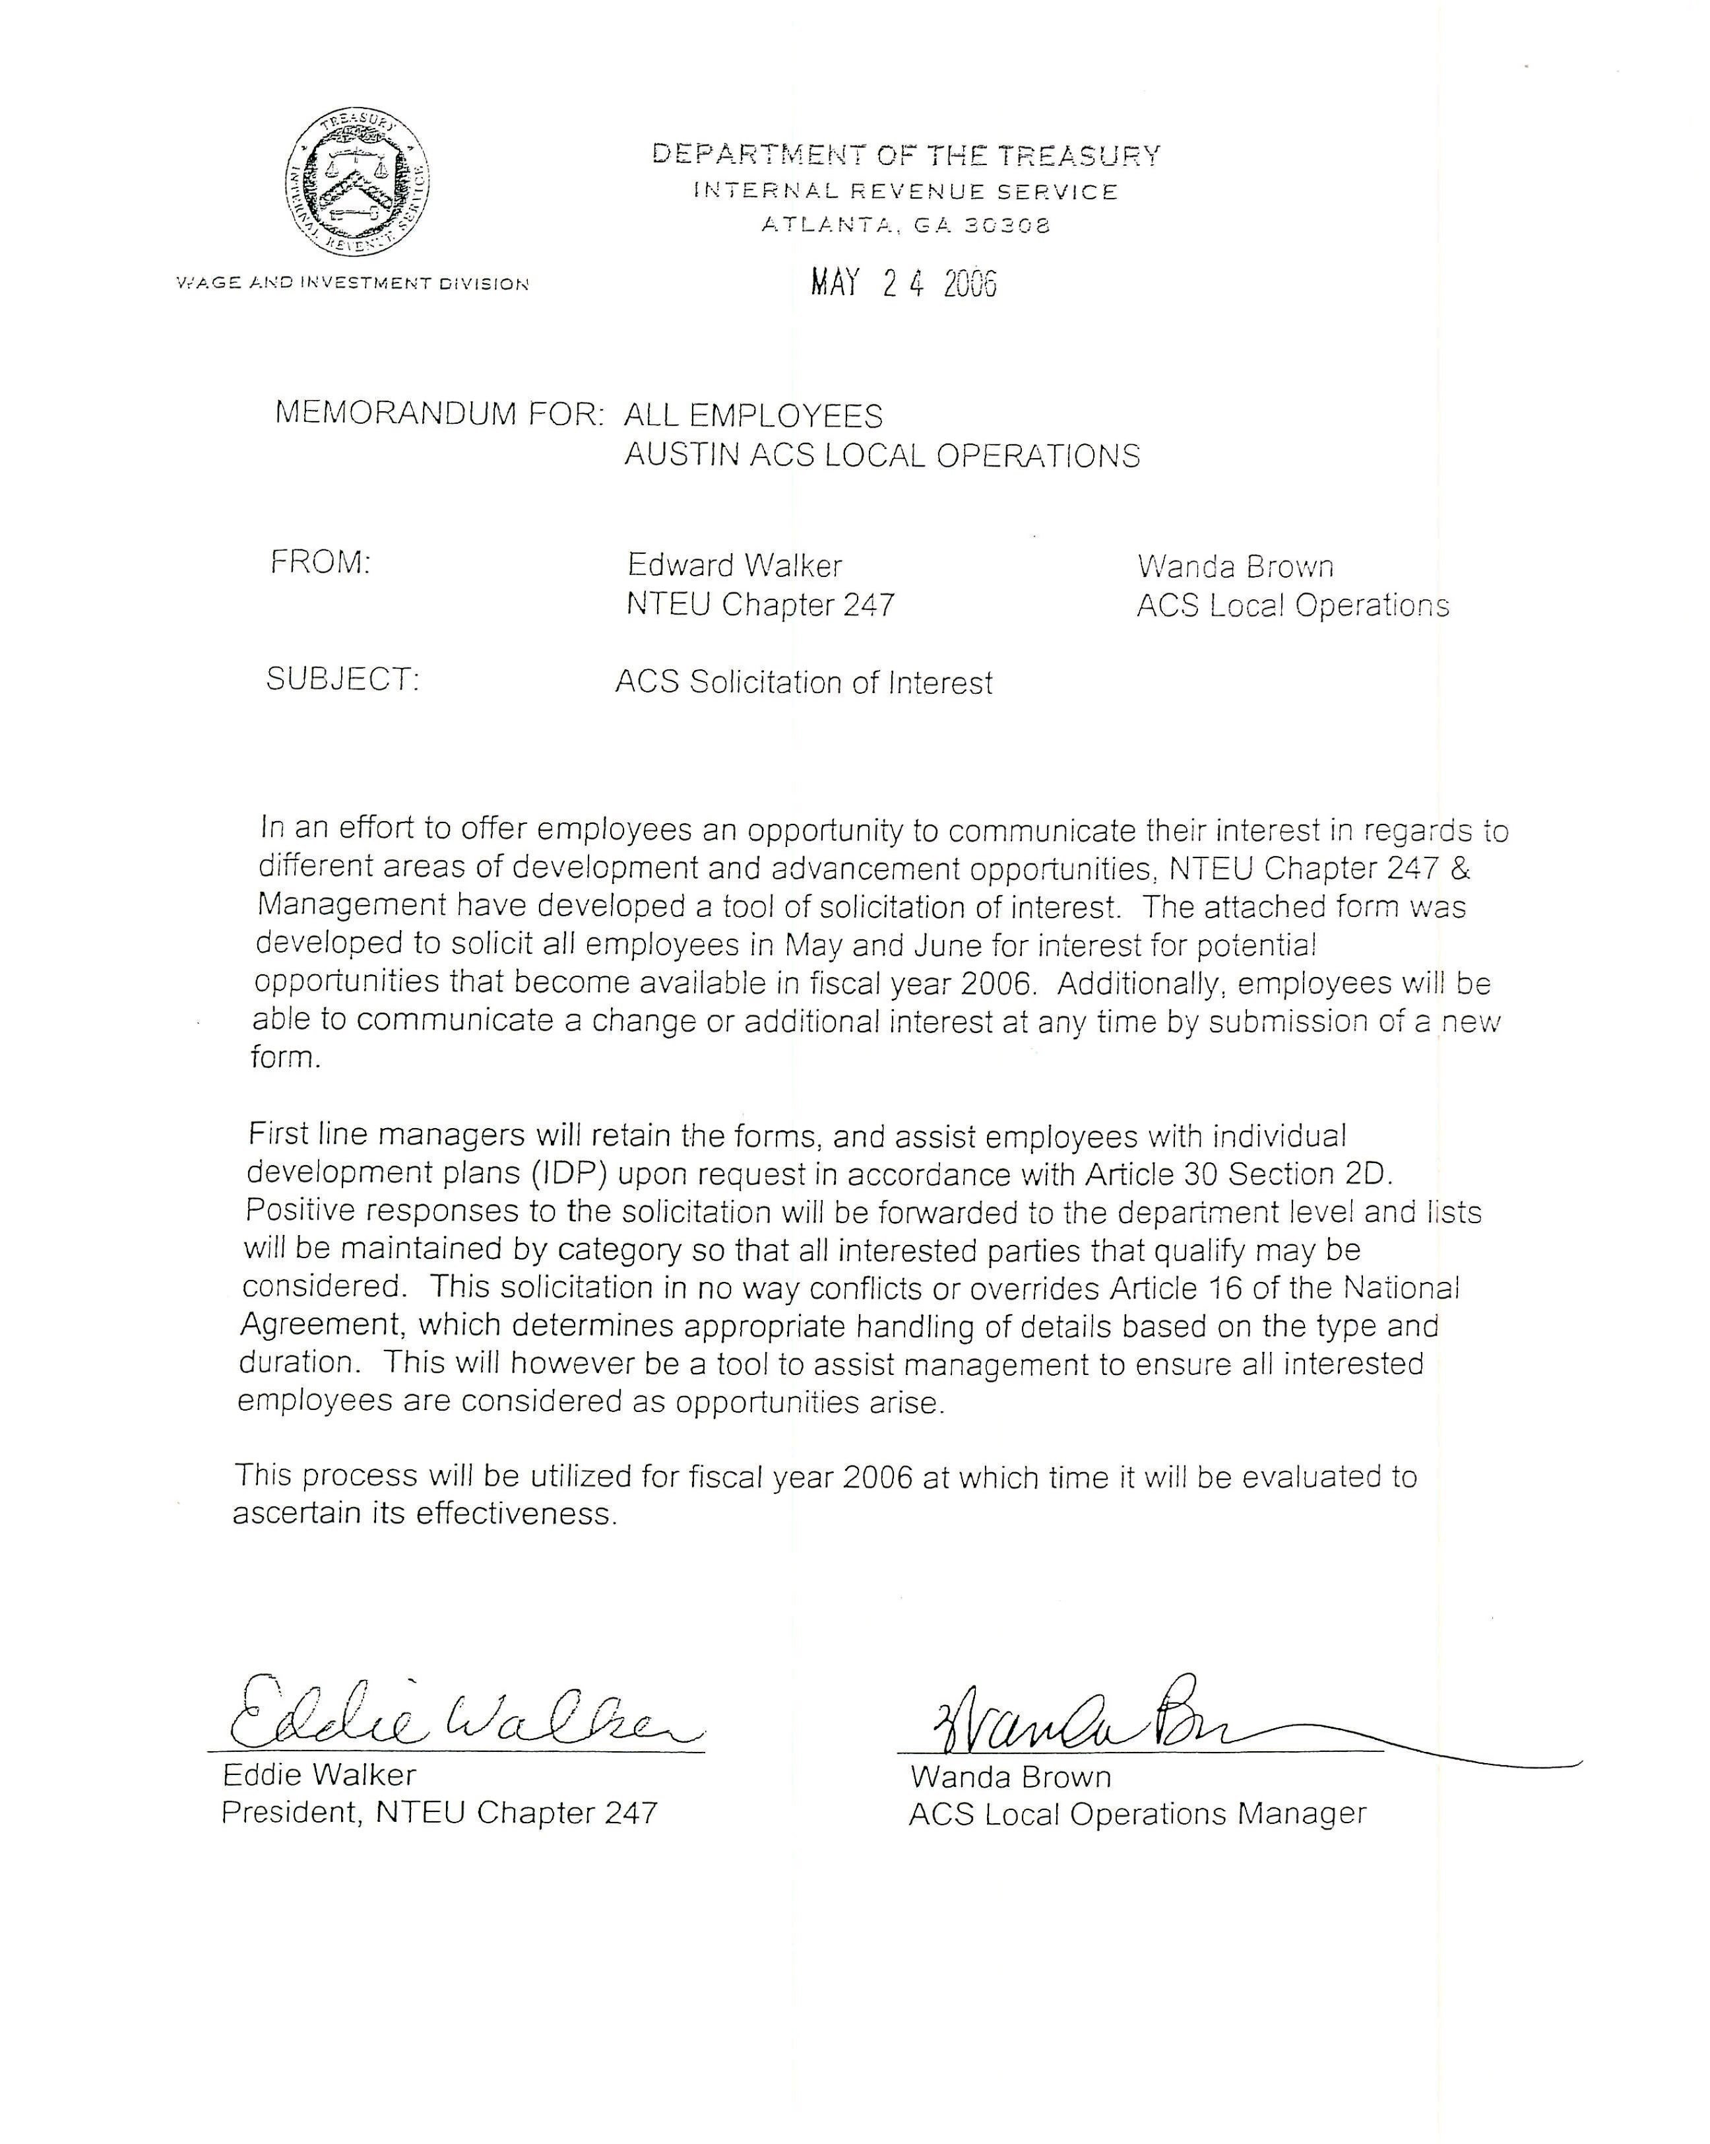

Solicitation of Interest

Austin ACS

Let us know if you would like to be considered for the following opportunities as they become available….
YES NO
Technical Specialist (Lead)
- Detail up to 120 days/short term ___ ___

On the Job Instructor (OJI)
- Detail up to 120 days/short term ___ ___

Acting Manager short period of time ___ ___

Class instructor ___ ___

Development Teams/Focus Groups
- Local ___ ___
- National (some travel may be involved) ___ ___

ACS Advisory Council ___ ___

My Opinion Counts ___ ___

Developmental Training ___ ___
(I.e. Skill soft, e-learning, IDP …)

Name __________________________ Date ________

EOD ___________________
(Revise 2/2006)
I & I Team

